TRƯỜNG ĐẠI HỌC HÀ NỘI
Cán bộ coi thi 1: ____________________
Cán bộ coi thi 2: ____________________
TRUNG TÂM ĐÀO TẠO TỪ XA
_____________

BÀI THI KẾT THÚC HỌC PHẦN THỰC HÀNH TIẾNG A2
VIẾT, CA THI: 03 KỲ THI NGÀY 16.02.2025
Hình thức đào tạo: Từ xa - Thời gian: 30 phút. Bài thi có 04 trang.
Thí sinh KHÔNG được dùng tài liệu.

Họ và tên thí sinh: …………………………………Giới tính:………… Số BD:….....
Ngày sinh: ..………………….Lớp:…..………….Mã sinh viên……………………...
Số phách:
✂-------------------------------------------------------------------------------------------------------------
Số phách:
Cán bộ chấm thi 1: __________________________
Cán bộ chấm thi 2: __________________________

Part 1 (3 points) Answer the following questions, using your own ideas:

- Why do some people prefer brand-name clothes over non-brand ones?
__________________________________________________________________________________________________________________________________________
- Do you think that all children should learn foreign languages at school?
__________________________________________________________________________________________________________________________________________
- Do you think the traditional roles of husbands and wives in Vietnam have changed?
__________________________________________________________________________________________________________________________________________
Part 2 (7 points) Write one paragraph (about 150 words) about ONE of the following topics
1. Some people say that the young generation now spend too much time on personal enjoyment – doing things they like to do – rather than doing things they should do. Do you agree with this point of view?
2. In some countries, many more people are choosing to live alone nowadays than in the past. Do you think this is a positive or negative development?
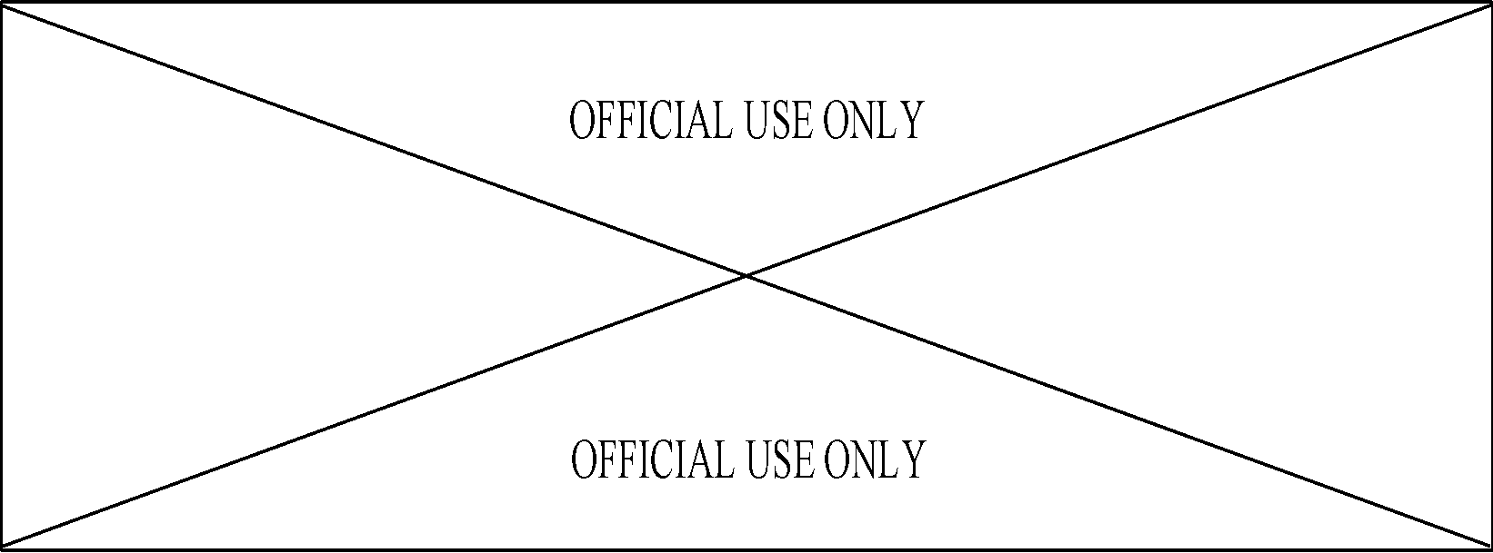
..................................................................................................................................................
..................................................................................................................................................
..................................................................................................................................................
..................................................................................................................................................
..................................................................................................................................................
..................................................................................................................................................
..................................................................................................................................................
..................................................................................................................................................
..................................................................................................................................................
..................................................................................................................................................
..................................................................................................................................................
..................................................................................................................................................
..................................................................................................................................................
..................................................................................................................................................
..................................................................................................................................................
..................................................................................................................................................
..................................................................................................................................................
..................................................................................................................................................
..................................................................................................................................................
..................................................................................................................................................
..................................................................................................................................................
..................................................................................................................................................
..................................................................................................................................................
..................................................................................................................................................
..................................................................................................................................................
..................................................................................................................................................
..................................................................................................................................................
..................................................................................................................................................
..................................................................................................................................................
..................................................................................................................................................
..................................................................................................................................................
..................................................................................................................................................
..................................................................................................................................................
..................................................................................................................................................
..................................................................................................................................................
..................................................................................................................................................
..................................................................................................................................................
..................................................................................................................................................
..................................................................................................................................................
..................................................................................................................................................
..................................................................................................................................................
..................................................................................................................................................
..................................................................................................................................................
..................................................................................................................................................
..................................................................................................................................................
..................................................................................................................................................
..................................................................................................................................................
..................................................................................................................................................
..................................................................................................................................................
..................................................................................................................................................
..................................................................................................................................................
..................................................................................................................................................
..................................................................................................................................................
..................................................................................................................................................
..................................................................................................................................................
..................................................................................................................................................
..................................................................................................................................................
..................................................................................................................................................
..................................................................................................................................................
..................................................................................................................................................
..................................................................................................................................................
..................................................................................................................................................
..................................................................................................................................................
..................................................................................................................................................
..................................................................................................................................................
..................................................................................................................................................
..................................................................................................................................................
..................................................................................................................................................
..................................................................................................................................................
..................................................................................................................................................
..................................................................................................................................................
..................................................................................................................................................
..................................................................................................................................................
..................................................................................................................................................
..................................................................................................................................................
..................................................................................................................................................
..................................................................................................................................................
..................................................................................................................................................
..................................................................................................................................................
..................................................................................................................................................
..................................................................................................................................................
..................................................................................................................................................
..................................................................................................................................................
..................................................................................................................................................
..................................................................................................................................................
..................................................................................................................................................
..................................................................................................................................................

THE END

